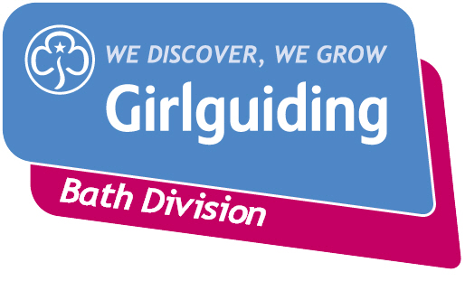

Request for Financial Assistance
This form is for units to apply for help if they have concerns about unit finances following the COVID-19 pandemic and feel they need financial help to successfully restart the unit in September 2021. All units can apply, even if they have received previous financial support from Bath Division. Please include as much detail as you can to help us make a decision.

Please return to treasurer@girlguidingbath.org.uk and copy in your district commissioner.

Forms must be received by 13th August 2021.

Unit name:
Leader name:

Amount requested | £
Are you requesting a grant or loan? | i.e. do you anticipate repaying some/all of the amount?
Reason for request (why do you need the grant/loan and what will you use it for)

Number of members in the unit | Girls:  Volunteers:
Current unit funds | Bank/building society: £  Cash: £
Do you claim gift aid? | Yes/no  If no, please say why.
How much will charge girls from September? | £ per week/month/term

Have you requested any subscriptions since March 2020? | Yes/no  If yes, how much and how often?  And how much have you received?
Do you have any costs due/owing that you want to make us aware of?

Please attach a copy of your 2020 accounts. If possible, also attached the latest accounts for 2021 (it is fine if these are in draft format).

Applications will be discussed in August and all applicants will be told the outcome of their application.

If successful we’d like to make payments promptly, ideally by the end of August. Please provide details of how you’d like the payment to be made: either address and name on account for a cheque, or sort code, account number and name on account for bank transfer. Payments can only be made to unit bank/building society accounts.

