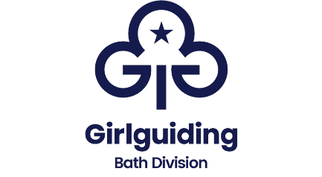

Annual Report 2022

The full return to face-to-face meetings and activities following the Covid
pandemic were welcomed by leaders and young members alike. In 2022 we welcomed a new Division Commissioner and Division Treasurer.

We offered Exceptional Experiences for Girls of all ages through their regular unit meetings, and through events and trips away. Guides went to large scale events, meeting Guides from across the region and beyond, at Fearless Fun and Strategy camps and a “Be Prepared” day. Girls from all ages went to special Girlguiding screenings of Matilda at the cinema. There were district activity days with a science theme and Brownie outdoor days with canoeing, archery and other adventurous activities. Brownies went on pack holidays and sleepovers and trips to the pantomime. At unit meetings, girls went star-gazing with Bath Astronomers, tree planting for the Queen’s Canopy project and, of course, toasted marshmallows! There was a fantastic outdoor promise ceremony with 15 new Brownies making their promise at the same time.

We aimed to provide a Rewarding Volunteer Experience. We reviewed how we welcome new volunteers and supported existing leaders to gain qualifications. We were very pleased when several volunteers completed their leadership qualifications and another completed her going away with license. One of our leaders was selected to join an international trip to Morocco and we were pleased to provide a grant to support her trip. A thanks and recognition event was held where we had the pleasure to present long service, county and region awards.

In trying to be Inclusive and Impactful, a range of communication methods have
been utilised to ensure good publicity, promote activities and improve our presence in the community. The division exec reviewed and then promoted grants to try to remove financial barriers to taking part in events.

To underlie the delivery of the programme to our young members we worked
towards Creating a Sustainable Organisation. We recruited an admin assistant, DBS co-ordinator and Go co-ordinator to support behind the scenes and reduce the burden on commissioners. We supported leaders to complete First Response and Safe Space training. Leaders and our Go Co-ordinator worked hard to make sure all girl enquiries were actioned promptly. Our new approach to volunteer welcome means that volunteers are assigned to where they are needed most. The number of young members and volunteers increased slightly between the start and end of the year.

Our volunteer-run shop has continued to allow members and parents to purchase uniform, badges, and guiding-themed gifts. The shop ran a reward scheme for Bath units and purchased some resources for us on the division, such as award books and promise badges for leaders, reducing the financial burden on units.

In November 2022 the Division Executive reviewed existing financial controls, and considered our reserves using information on historic and predicted spending.

