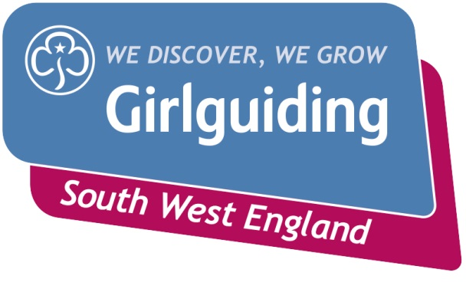

**Peer Education Basic Training Weekend**

**11th - 13th October 2019**

**A fun filled weekend where you will make new friends, develop new skills and improve your confidence.**

**Who and what are Peer Educators?**

Peer Educators are trained members between 14 and 25 who run sessions for Brownies, Guides and Rangers.

They also work with other youth groups or schools. These sessions focus on issues or skills that are important to them and their peers such as:

* Mental Health 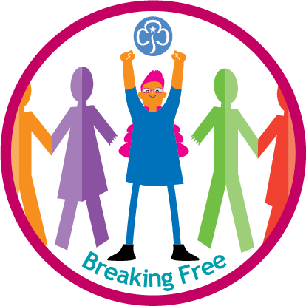
* Self Esteem
* Gender Stereotypes

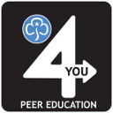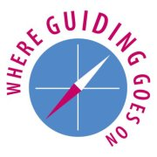

**How do I become a Peer Educator?**

To gain the skills required to become a Peer Educator you need to complete the peer education e-learning, Safe Space levels 1 & 2 and attend a Peer Education Basic Training Weekend.

**Where:** Uphill Scout HQ, Windwhistle Lane, Weston-Super-Mare, BS23 4PE

**When:** 11th - 13th October 2019

**Cost: £30**

On day one you will explore the skills and methods used in peer education through different activities and gain practical tools like game ideas. On day two you will take part in topic training.

By the end of the weekend you will be equipped with the information you need to get going on topics and have received advice on how to get Peer Education started in your area.

**Interested?**

**Apply online at:** **www.girlguidingsouthwestevents.co.uk**

**Deadline for applications:**

**Sunday 8th September 2019**

**For questions email: vikki@ggswe.org.uk**