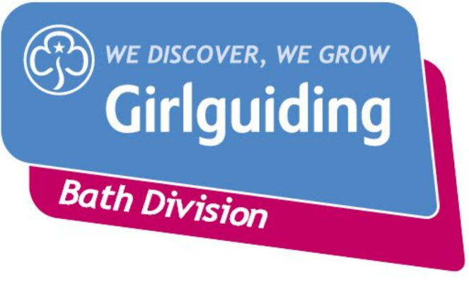

Dear Rainbows, Brownies and Guides
You are warmly invited to participate in the 2km Bath Odd Down Junior Parkrun on Sunday 19th May 2019. The course is specifically designed for 4 to 14 year olds in mind.
The run (which is not a race!) starts at 9.00am but participants must arrive at 8.45am for a short briefing and warm-up. The run is usually all finished by 9.30am after which refreshments will be laid on by Girlguiding Bath.
The event takes place at Odd Down Sports Ground, Chelwood Drive, Bath, BA2 2PR.
The event itself is free to participate but you might like to bring a few pennies for refreshments afterwards or to purchase the special event badge if you haven’t pre-ordered.
Please wear suitable running trainers and your Rainbow / Brownie / Guide Tshirt so that you are easily identifiable. It is a good idea to bring warm clothing for before and after the event.
This is a public event which means that that parents and guardians are usually expected to accompany their child for the whole duration. However if your Unit Leader is attending, they can count as your guardian. Nevertheless, as this is such a short event, parents may prefer to stay and watch. Some parents may want to run alongside younger children if they feel they need to.
Runners and volunteers must register before the event in order to have run times officially recorded. Runners can run without being registered but they will not receive a time. Please follow these simple instructions.
1. Go to www.parkrun.org.uk/register
2. Follow the simple online registration instructions
3. Print your barcode – NO BARCODE = NO OFFICIAL RECORDED TIME
4. Run with your barcode

For more information visit https://www.parkrun.org.uk/bathodddown-juniors/
This is a Girlguiding Bath Division event. Groups who get the most girls to participate will receive a prize! Please complete the consent form and return to your Unit Leader along with £1.60 cash if you would like to purchase the special event badge.

